Step 0 Source: Intake Result: Filing Status, Dependency
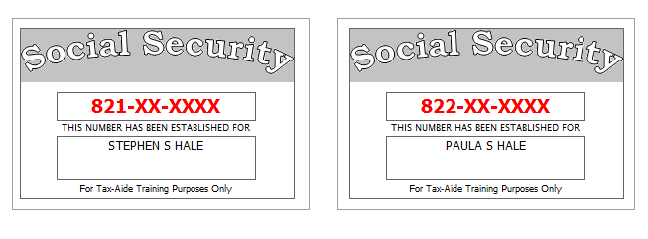
Stephen’s sister, Wanda Winters, lived with them all year. She is totally and permanently disabled and relies upon her brother for her support. She receives $250 per month in social security benefits. She is covered by Medicare.
Paula has less than 20/200 vision in both eyes. She provided a doctor’s statement.
Reference: 4012 Tab A, B, C
Tool: IRS Interactive Tax Assistant (link on Preparer page)
Tool: AARP Resource Tool for Counselors (Laminated Flow Chart)
Tool: TP4F Qualifying Child/Qualifying Relative Flowchart Tool (link on Preparer page)
Tool: Dependent Calculator (link on Preparer page)

Step 1a Source: Intake Part I, II, VII TWO Screen: Main Info
Reference: 4012 K-6, K-7, K-22
Use the Filing Status and Dependency Status from Step 0
Refund Monitor
AGI | Refund | NJ 39 | NJ 56/66 | Notes
 |  |  |  | Hint: Don’t worry about RTN / DAN for direct deposit at this point.
Step 1b Source: Intake Part I TWO Screen: NJ 1040 Pg1
They lived in Dover (Morris County) for the first half of the year (through June 30) and in Pluckemin (Somerset County) for the second half of the year.
Reference: NJ Special Handling p5
Tool: NJ Municipality Code Lookup Tool (link on Preparer page)
Tool: NJ 1040 Instructions – Municipality Code Table
Tool: TWO State Help
Refund Monitor
AGI | Refund | NJ 39 | NJ 56/66 | Notes
Hint: Use NJ Municipality Code Lookup Tool
Hint: Are there any other questions on this page that should be answered?
Step 1c Source: Intake Part VII TWO Screen: NJ 1040 Pg 2
Stephen and Paula want their contribution to the Gubernatorial Election Campaign Fund to be handled the same as their contribution to the Presidential Election Campaign Fund.
Everyone on the return had MEC (Not from the Marketplace) all year.
Reference: NJ Special Handling p5
Refund Monitor
AGI | Refund | NJ 39 | NJ 56/66 | Notes
 |  |  |  | Hint: Gubernatorial Elections Fund – see Notes
Step 1d Source: Intake Part VII TWO Screen: Prep Use
If asked, neither Steve nor Paula is a Veteran from the US Armed Forces.
Refund Monitor
AGI | Refund | NJ 39 | NJ 56/66 | Notes
 |  |  |  | BP: Do not fill in line 14 until after QR

Step 2a Source: Prior Year Return TWO Screen: 1040 Pg 1
Although they received a federal refund on last year’s return, they owed $203 to NJ
Refund Monitor
AGI | Refund | NJ 39 | NJ 56/66 | Notes
0 | 0 | 0 | 0 | Hint: Answer the question above line 10
Step 2b Source: Prior Year Return TWO Screen: F/S Tax Pd
Although they received a federal refund on last year’s return, they owed $203 to NJ (which they paid on time). The also owed $42 from their NJ return from three years ago, which they paid on 06-15-2014.
Reference: NJ Special Handling p11
Refund Monitor
AGI | Refund | NJ 39 | NJ 56/66 | Notes
0 | 0 | 0 | 0 | BP: Use a Scratch Pad attached to “NJ state and/or local balance due…” to document multiple payments (and manually un-red box)  Check: Sch A, Line 5a = 245
Step 2c Source: Prior Year Return TWO Screen: Sch D Pg 1
Their prior year return (not prepared at your site) shows a long-term capital loss carryover of $15,454. There is no short-term capital loss carryover.
Refund Monitor
AGI | Refund | NJ 39 | NJ 56/66 | Notes
(3,000) | 0 | 0 | 0 | Hint: Might as well un-red Sch D, Line 6 while screen is open  Check: 1040 Pg 1, Line 13 = -3,000

Step 3 Source: 1099-R TWO Screen: 1099R
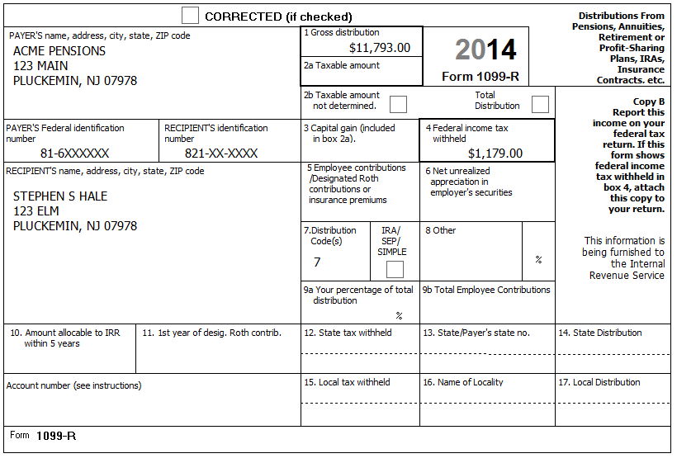
Reference: 4012 D-20, D-21, D-27 A. Example 1
Refund Monitor
AGI | Refund | NJ 39 | NJ 56/66 | Notes
8,793 | 1,179 | 0 | 0 | Hint: Can make red box 2 un-red – box 1 amount will be used for taxable amount  Check: NJ 1040, line 19a = 11,793; Line 28 = 0
Step 4a Source: 1099-R TWO Screen: 1099R
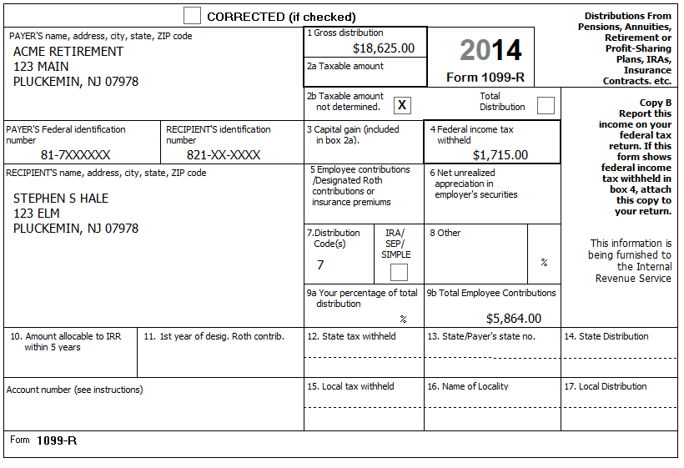
Stephen receives a pension from Acme Retirement for his years as a member of the International Brotherhood of Electrical Workers. He retired on January 1, 2011. Paula, who is a housewife, is covered by the plan. He recovered a total of $681 of his cost in previous years.
Reference: 4012 D-20, D-21, D-24, D-27 B. Example 2
Reference: NJ Special Handling p3
Tool: Annuity Calculator (link on Preparer page)
Refund Monitor
AGI | Refund | NJ 39 | NJ 56/66 | Notes
27,191 | 2,840 | 4,691 | 0 | Hint: Annuity Calculator tool helpful for filling Simplified Method section  Check: 1099R, Simplified Method Line 7 = 4,956  Check: NJ 1040, line 19a = 30,191; Line 28 = 10,191

Step 4b Source: 1099R TWO Screen: NJ 1040 Pg 2, Line 19b
* Scratch Pad attached to NJ 1040 Pg 2, Line 19b
Reference: NJ Special Handling p5
Refund Monitor
AGI | Refund | NJ 39 | NJ 56/66 | Notes
27,191 | 2,840 | 4,691 | 0 | Hint: Follow procedure in NJ Special Handling, p5 for NJ 1040 Pg 2, Line 19b (Excludable pensions)  Check: NJ 1040, line 19b = 227
Step 5 Source: SSA-1099 TWO Screen: 1040 Wkt1
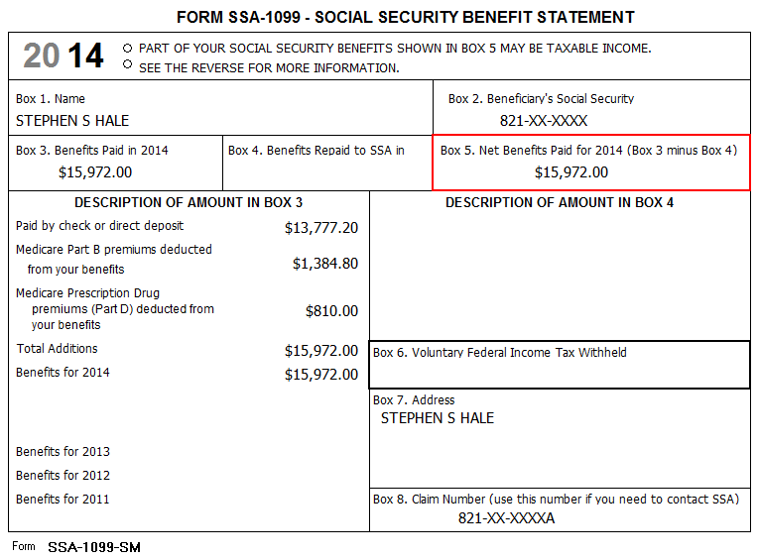
Reference: 4012 D-26
Refund Monitor
AGI | Refund | NJ 39 | NJ 56/66 | Notes
28,780 | 2,680 | 2,700 | 0 | BP: Use Scratch Pad linked to “Medicare Parts B, C, and D to Schedule A” row, Taxpayer column to document breakdown of Medicare premiums if more than one of Part B, C, D  Check: A Detail, Medicare from 1040 worksheet box = 2,195  Q: Why is NJ line 39 going down?
Step 6 Source: SSA-1099 TWO Screen: 1040 Wkt1
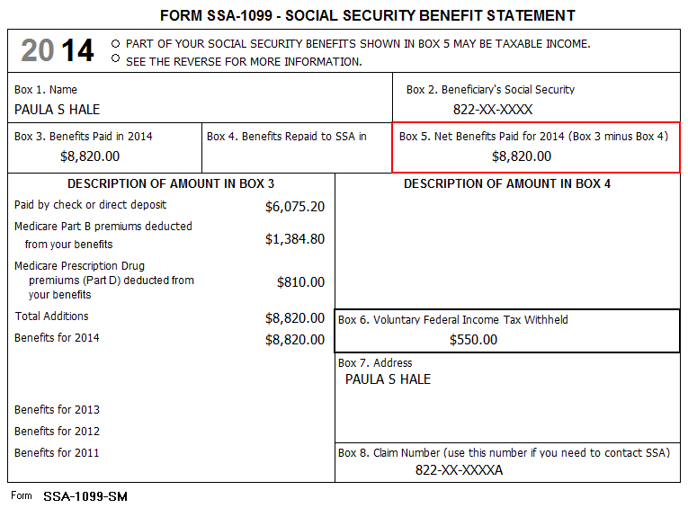
Reference: 4012 D-26
Refund Monitor
AGI | Refund | NJ 39 | NJ 56/66 | Notes
30,985 | 3,011 | 505 | 0 | BP: Use Scratch Pad linked to “Medicare Parts B, C, and D to Schedule A” row, Spouse column to document breakdown of Medicare premiums if more than one of Part B, C, D  Check: A Detail, Medicare from 1040 worksheet box = 4.390
Step 7 Source: K-1 TWO Screen: See Sub-Steps
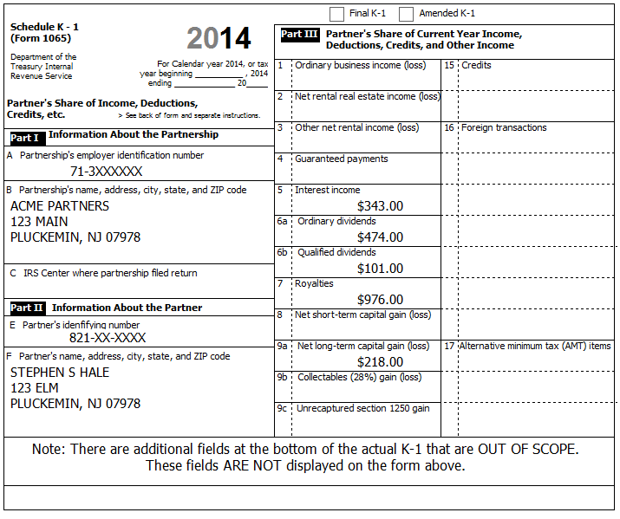
Reference: Special Topic Document – K-1 Income Entry
Step 7a Source: K-1 TWO Screen: Interest Stmt
Refund Monitor
AGI | Refund | NJ 39 | NJ 56/66 | Notes
31,499 | 2,961 | 855 | 0 | Hint: Do NOT use K-1 form in TW !  Q: Why does AGI go up by 514 if interest amount was only 343?  Q: Why does NJ 39 go up by 350 if interest amount was only 343?
Step 7b Source: K-1 TWO Screen: Dividend Stmt
Refund Monitor
AGI | Refund | NJ 39 | NJ 56/66 | Notes
32,210 | 2,896 | 1,338 | 0 | Hint: Do NOT use K-1 form in TW !
Step 7c Source: K-1 TWO Screen: Sch E Pg 1
No payments were made that would require filing Form(s) 1099.
Refund Monitor
AGI | Refund | NJ 39 | NJ 56/66 | Notes
33,674 | 2,751 | 2,334 | 0 | Hint: Do NOT use K-1 form in TW !  Hint: Probably need to manually add Sch E to tree
Step 7d Source: K-1 TWO Screen: Sch D Pg 1
Refund Monitor
AGI | Refund | NJ 39 | NJ 56/66 | Notes
33,674 | 2,751 | 2,556 | 0 | Hint: Do NOT use K-1 form in TW !  BP: Use Scratch Pad attached to Sch D, Line 12 to document source of amount  Q: Federal AGI doesn’t change – why?  Q: Cap Gain amount is 218, but NJ 39 goes up by 222 – why?

Step 8 Source: 1099-INT TWO Screen: Interest Stmt
Acme Financial | End of Year Tax Information Statement  Tax Year 2014 • Account 203040506 | Statement Date: 01-30-2015  Page 1 of 4 | 2014
123 Main  P.O. Box 07978-123  Pluckemin, NJ 07978  PAYER’S Federal ID No: 71-9XXXXXX | Stephen S. Hale  123 Elm  Pluckemin, NJ 07978  RECIPIENT’S ID No: 821-XX-XXXX | Your Broker:  SERGE BRONSKI  888-555-5555  sbronski@rjones.com

Interest Income – 1099-INT – Reported to IRS
1 | Interest Income (not included in line 3) | 124.73
2 | Early withdrawal penalty | 0.00
3 | Interest on US Savings Bonds & Treasury obligations | 506.00
4 | Federal Income tax withheld | 50.60
5 | Investment expenses | 0.00
6 | Foreign tax paid | 0.00
7 | Foreign country or US possession
8 | Tax-exempt interest (includes line 9) | 337.86
9 | Specified private activity bond interest (AMT) | 0.00
10 | Tax-exempt bond CUSIP numbers (see instructions)
11 | State
12 | State ID numbers
13 | State tax withheld | 0.00
 | FATCA filing requirement | NO

Interest Detail (only summary 1099-INT reported to IRS)
Date | 1 Interest Income | 2 Early withdrawal penalty | 3 Interest on US Savings Bonds | 4 Federal withholding | 8 Tax-exempt interest
Safe Stuff
12-30-2014 | 124.73 | 0.00 | 506.00 | 50.60 | 0.00
New Jersey Muni Bond
03-15-2014 | 0.00 | 0.00 | 0.00 | 0.00 | 37.16
06-15-2014 | 0.00 | 0.00 | 0.00 | 0.00 | 37.16
09-15-2014 | 0.00 | 0.00 | 0.00 | 0.00 | 37.16
12-15-2014 | 0.00 | 0.00 | 0.00 | 0.00 | 37.16
Total | 0.00 | 0.00 | 0.00 | 0.00 | 148.64
New York Muni Bond
12-30-2014 | 0.00 | 0.00 | 0.00 | 0.00 | 189.22
Totals: | 124.73 | 0.00 | 506.00 | 50.60 | 337.86

The Savings Bond interest was not used for any tax-exempt purpose.
Reference: 4012 D-9
Reference: NJ Special Handling p1, p2
Refund Monitor
AGI | Refund | NJ 39 | NJ 56/66 | Notes
34,790 | 2,692 | 2,876 | 0 | Hint: Easier if use separate line for each type of interest  Check: Fed 1040, line 8a=974, 8b=338  Check: NJ 1040, line 15a=657, 15b=655

Step 9 Source: 1099-DIV TWO Screen: Various
Acme Financial | End of Year Tax Information Statement  Tax Year 2014 • Account 203040506 | Statement Date: 01-30-2015  Page 2 of 4 | 2014
123 Main  P.O. Box 07978-123  Pluckemin, NJ 07978  PAYER’S Federal ID No: 71-9XXXXXX | Stephen S. Hale  123 Elm  Pluckemin, NJ 07978  RECIPIENT’S ID No: 821-XX-XXXX | Your Broker:  SERGE BRONSKI  888-555-5555  sbronski@rjones.com

Dividends and Distributions – 1099-DIV – Reported to IRS
1a | Total ordinary dividends (includes line 1b) | 231.86
1b | Qualified dividends | 125.25
2a | Total capital gain distributions (includes lines 2b, 2c, 2d) | 68.75
2b | Unrecaptured Section 1250 gain | 0.00
2c | Section 1202 gain | 0.00
2d | Collectibles (28%) gain | 0.00
3 | Nondividend distributions | 32.44
4 | Federal Income tax withheld | 0.00
5 | Investment expenses | 0.00
6 | Foreign tax paid | 43.75
7 | Foreign country or US passion
8 | Cash liquidation distributions | 0.00
9 | Noncash liquidation distributions | 0.00
10 | Exempt-interest dividends (includes line 11) | 400.00
11 | Specified private activity bond interest dividends (AMT) | 22.00
12 | State
13 | State ID number
14 | State tax withheld | 0.00
 | FATCA filing requirement | NO

Dividend Detail (only summary 1099-DIV reported to IRS)
Date | 1a Ordinary dividends | 1b Qualified dividends | 2a Capital gains | 3 Nondiv. Dists. | 4 Federal w/h | 6 Foreign tax paid | 10 Exempt Interest | 11 Sp. PAB
Boring Mutual Fund (BMF)
12-30-2014 | 231.86 | 125.25 | 68.75 | 32.44 | 0.00 | 43.75 | 0.00 | 0.00
Select US Tax-Exempt Fund (SUSTE)
12-30-2014 | 0.00 | 0.00 | 0.00 | 0.00 | 0.00 | 0.00 | 200.00 | 0.00
Select NJ Qualified Fund (SNJQTE)
12-30-2014 | 0.00 | 0.00 | 0.00 | 0.00 | 0.00 | 0.00 | 200.00 | 22.00
Totals: | 231.86 | 125.25 | 68.75 | 32.44 | 0.00 | 43.75 | 400.00 | 22.00

Exempt-Interest Dividends by Area
Area | SUSTE | SNJQTE
Alabama | 1.3% | -
Alaska … Nevada | 28.2% | -
New Hampshire | 0.5% | -
New Jersey | 10.0% | 70.0%
New Mexico | 0.7% | -
New York … Wisconsin | 29.1% | 7.0%
Wyoming | 0.2% | -
District of Columbia obligations | 0.2% | 1.0%
Puerto Rico obligations | 9.7% | 2.0%
US Possessions obligations | 20.1% | 20.0%
Step 9a Source: 1099-DIV TWO Screen: Dividend Stmt
Reference: 4012 D-11
Reference: NJ Special Handling p2
Refund Monitor
AGI | Refund | NJ 39 | NJ 56/66 | Notes
35,338 | 2,647 | 3,340 | 0 | Check: Fed 1040, line 8a=974; 8b=738; 9a=706  Check: NJ 1040, line 15a=657; 15b=901; 16=860
Step 9b Source: 1099-DIV TWO Screen: 1116 Pg 1
Reference: 4012 G-2
Refund Monitor
AGI | Refund | NJ 39 | NJ 56/66 | Notes
35,338 | 2,691 | 3,340 | 0 | Hint: May need to manually add 1116 Pg 1  Hint: Do NOT worry about red stuff on form 1116 below “Simplified Limitation Election”

Step 10 Source: 1099-B TWO Screen: Cap Gn Wkt
Acme Financial | End of Year Tax Information Statement  Tax Year 2014 • Account 203040506 | Statement Date: 01-30-2015  Page 3 of 4 | 2014
123 Main  P.O. Box 07978-123  Pluckemin, NJ 07978  PAYER’S Federal ID No: 71-9XXXXXX | Stephen S. Hale  123 Elm  Pluckemin, NJ 07978  RECIPIENT’S ID No: 821-XX-XXXX | Your Broker:  SERGE BRONSKI  888-555-5555  sbronski@rjones.com

FORM 1099-B 2015 Proceeds from Broker and Barter Exchange Transactions
Long-term transactions for which basis is not reported to the IRS - Report on form 8949 with Box E checked
1a Description, 2 Long-term, 3 Basis not reported to IRS, 6 Net Proceeds
Quantity | 1b Date Acquired | 1c Date Sold | 1d Proceeds | 1e Cost or other Basis | 1f Code | 1g Adj | Gain / Loss(-) | 4 Federal Tax Withheld
Acme Corp (ZACO)
50.000 | 09-01-1992 | 05-10-2014 | 3,462.00 | 3.181.00 |  |  | 281.00 | 0.00
100.000 | 09-01-1992 | 10-20-2014 | 7,226.00 | 6,362.00 |  |  | 864.00 | 0.00
150.000 |  |  | 10,688.00 | 9,543.00 |  | 0.00 | 1.145.00 | 0.00
Acme Inc (ZAI)
65.000 | ** | 10-20-2014 | 5.663.00 | ** |  |  | ** | 0.00
Totals |  |  | 16,351.00 |  |  |  |  | 0.00
** Information not available

Acme Financial does not have a record for the purchase of ZAI stock. Stephen inherited the 65 shares from his uncle who paid $6,500 for the shares on 10/15/2005. The stock was worth $7,222 on 11/29/2008, the day his uncle died.
Reference: 4012 D-16 to D-18
Refund Monitor
AGI | Refund | NJ 39 | NJ 56/66 | Notes
35,338 | 2,691 | 3,048 | 0 | Check: Sch D Pg 1, Long-term totals = -414; Line 15 = -15,581  Check: NJ 1040 Pg 2, Line 18 = 0

Step 11 Source: 1099-B TWO Screen: Cap Gn Wkt
Acme Financial | End of Year Tax Information Statement  Tax Year 2014 • Account 203040506 | Statement Date: 01-30-2015  Page 4 of 4 | 2014
123 Main  P.O. Box 07978-123  Pluckemin, NJ 07978  PAYER’S Federal ID No: 71-9XXXXXX | Stephen S. Hale  123 Elm  Pluckemin, NJ 07978  RECIPIENT’S ID No: 821-XX-XXXX | Your Broker:  SERGE BRONSKI  888-555-5555  sbronski@rjones.com

FORM 1099-B 2015 Proceeds from Broker and Barter Exchange Transactions
Long-term transactions for which basis is reported to the IRS - Report on form 8949 with Box D checked
1a Description, 2 Long-term, 3 Basis reported to IRS, 6 Net Proceeds
Quantity | 1b Date Acquired | 1c Date Sold | 1d Proceeds | 1e Cost or other Basis | 1f Code | 1g Adj | Gain / Loss(-) | 4 Federal Tax Withheld
Acme Corp (ZACO)
10.000 | 07-02-1999 | 01-15-2014 | 350.00 | 340.00 |  |  | 10.00 | 0.00
10.000 | 07-02-1999 | 02-15-2014 | 340.00 | 340.00 |  |  | 0.00 | 0.00
10.000 | 07-02-2000 | 03-15-2014 | 350.00 | 320.00 |  |  | 30.00 | 0.00
10.000 | 07-02-2000 | 04-15-2014 | 340.00 | 320.00 |  |  | 20.00 | 0.00
10.000 | 07-02-2000 | 05-15-2014 | 350.00 | 320.00 |  |  | 30.00 | 0.00
10.000 | 07-02-2000 | 06-15-2014 | 340.00 | 320.00 |  |  | 20.00 | 0.00
10.000 | 07-02-2000 | 07-15-2014 | 350.00 | 320.00 |  |  | 30.00 | 0.00
10.000 | 07-02-2000 | 08-15-2014 | 340.00 | 320.00 |  |  | 20.00 | 0.00
10.000 | 07-02-2000 | 09-15-2014 | 350.00 | 320.00 |  |  | 30.00 | 0.00
10.000 | 07-02-2000 | 10-15-2014 | 340.00 | 320.00 |  |  | 20.00 | 0.00
10.000 | 07-02-2000 | 11-15-2014 | 350.00 | 320.00 |  |  | 30.00 | 0.00
10.000 | 07-02-2000 | 12-15-2014 | 340.00 | 320.00 |  |  | 20.00 | 0.00
120.000 |  |  | 4,140.00 | 3,880.00 |  | 0.00 | 260.00 | 0.00
Acme Inc (ZAI)
30.000 | 07-02-2004 | 03-15-2014 | 330.00 | 300.00 |  |  | 30.00 | 0.00
30.000 | 07-02-2004 | 06-15-2014 | 330.00 | 300.00 |  |  | 30.00 | 0.00
30.000 | 07-02-2005 | 09-15-2014 | 330.00 | 340.00 | W | 20.88 | -10.00 | 0.00
30.000 | 07-02-2005 | 12-15-2014 | 330.00 | 340.00 |  |  | -10.00 | 0.00
120.000 |  |  | 1.320.00 | 1,280.00 |  | 20.88 | 40.00 | 0.00
Acme Ltd (ZALTD)
30.000 | 07-02-2004 | 03-15-2014 | 3,210.00 | 700.00 |  |  | 2,510.00 | 0.00
30.000 | 07-02-2004 | 06-15-2014 | 3,220.00 | 700.00 |  |  | 2,520.00 | 0.00
30.000 | 07-02-2005 | 09-15-2014 | 3,230.00 | 720.00 |  |  | 2,510.00 | 0.00
30.000 | 07-02-2005 | 12-15-2014 | 3,240.00 | 720.00 |  |  | 2,520.00 | 0.00
120.000 |  |  | 12,900.00 | 2,840.00 |  | 0.00 | 10,060.00 | 0.00
Totals |  |  | 18,360.00 | 8,000.00 |  | 20.88 | 10,360.00 | 0.00

After checking with your LC / ERO, it is ok for you to consolidate these transactions.
Reference: Special Topic: Consolidating Capital Gains (ST14-12)

Refund Monitor
AGI | Refund | NJ 39 | NJ 56/66 | Notes
35,338 | 2,691 | 13,507 | (189) | Check: Sch D Pg 1, Long-term totals = 9,967; Line 15 = -5,200  Check: Sch D Wkt 2, Line 13 = 2,200  Check: NJ 1040 Pg 2, Line 18 = 10,254
Step 12 Source: Notes TWO Screen: 1040 ACA Wkt
Everyone on the return had MEC (Not from the Marketplace) all year.
Reference: 4012 ACA Tab
Reference: ACA TaxWise Procedures (TY2014 version)
Refund Monitor
AGI | Refund | NJ 39 | NJ 56/66 | Notes
35,338 | 2,691 | 13,507 | (189) | Hint: Everyone marked as Full
Step 13 Source: Notes TWO Screen: Diagnostics
Should be done with Federal return – Run Diagnostics – Resolve any issues.
Step 14 Source: Notes TWO Screen: F/S Tax Pd
They made the following NJ estimated payments:
Tax Year | TY2013 | TY2014 | TY2014 | TY2014 | TY2014
Date | 01-03-2014 | 04-14-2014 | 06-15-2014 | 09-11-2014 | 12-28-2014
Amount | $50.00 | $60.00 | $60.00 | $60.00 | $70.00

Reference: 4012 H-3
Reference: NJ Special Handling p11
Refund Monitor
AGI | Refund | NJ 39 | NJ 56/66 | Notes
35,338 | 2,691 | 13,507 | 61 | Check: Sch A, line 5a = 545  Check: NJ 1040 Pg 3, Line 50 = 250
Step 15 Source: Notes TWO Screen: NJ 1040 Pg 3, Line 45
Stephen and Paula discovered last year that they could buy things online and not pay NJ sales taxes so they did some Christmas shopping and purchased various other items online. When the NJ Use Tax rules were explained to them, they decided they better follow the NJ guidelines for reporting Use Tax on their NJ return because they had no easy way to calculate an exact total of purchases. None of the items cost more than $1,000.
Reference: NJ 1040 Instructions or link to Use Tax table on Preparer page
Refund Monitor
AGI | Refund | NJ 39 | NJ 56/66 | Notes
35,338 | 2,691 | 13,507 | 17 | Hint: Use NJ 1040, Line 28 amount to look up estimated amount in chart  BP: Use Scratch Pad linked to Line 45 to document how Use Tax amount was calculated  Hint: Will still need to un-red line 45

Step 16 Source: Notes TWO Screen: NJ 1040 Pg 3, Worksheet F
They lived in Dover (Morris County) for the first half of the year (through June 30) and in Pluckemin (Somerset County) for the second half of the year. They paid $1,000 per month in rent for the Dover apartment and $1,100 per month rent for the new Pluckemin apartment. They paid rent on both apartments in June and July.
Reference: NJ Special Handling p12
Refund Monitor
AGI | Refund | NJ 39 | NJ 56/66 | Notes
35,338 | 2,691 | 13,507 | 67 | BP: Use Scratch Pad attached to Wkt F, Rent box to document total rent calculation
Step 17 Source: Notes TWO Screen: Diagnostics
Should be done with NJ return – Run Diagnostics – Resolve any issues.
Step 18 Source: Intake TWO Screen: 1040 Pg 2
Refund via check for federal refund – nothing to do.
Step 19 Source: Notes TWO Screen: NJ DD Wkt
They would like any NJ refund or amount due handled the same way as on their federal return.
Refund Monitor
AGI | Refund | NJ 39 | NJ 56/66 | Notes
35,338 | 2,691 | 13,507 | 67 | Hint: Select appropriate option
Step 20 Source: Notes TWO Screen: NJ ES Wkt
They ask you to prepare TY2015 NJ estimated payment vouchers for $50 each quarter.
Refund Monitor
AGI | Refund | NJ 39 | NJ 56/66 | Notes
35,338 | 2,691 | 13,507 | 67 | Hint: Probably need to manually add NJ ES Wkt to tree  Hint: Only need to enter one number in one box to get all four vouchers for $50 per quarter
Step 21 Source: Notes TWO Screen: Diagnostics
Run Diagnostics (and Create e-File) – Resolve any issues
For a client return, the next step would be Quality Review…

